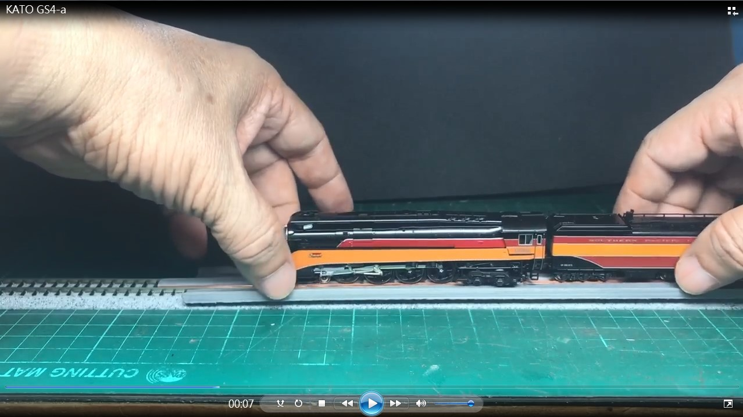
We would like to share our N scale Powered-Rerailer design to all the model train fans as below. It is powered and able to run bigger America locomotives like: big boy, challenger, Y6b…. Here have twp 3D STL files, one is the body and bottom, you are able to 3D print them. The pictures and description will tell you how to assembly it and hope everyone enjoy the model train.
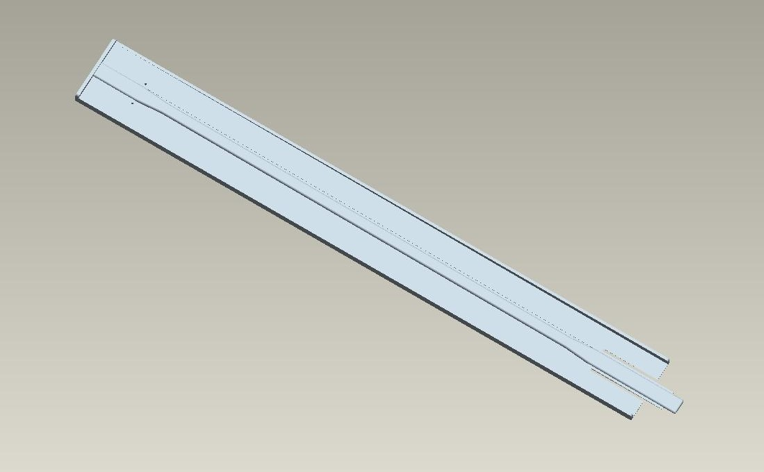

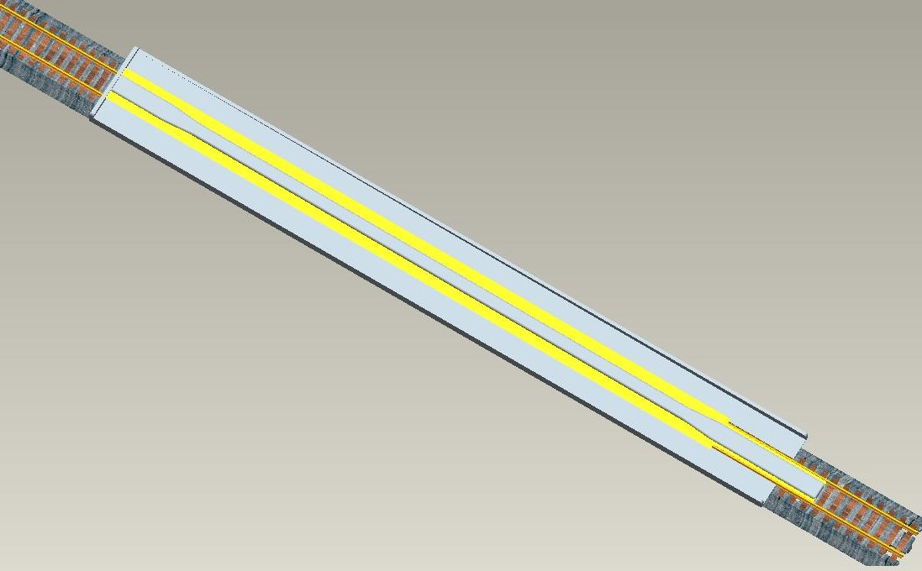

The conductive brass sheet wider is 4mm in the picture, the wider brass conductive brass sheet the better.
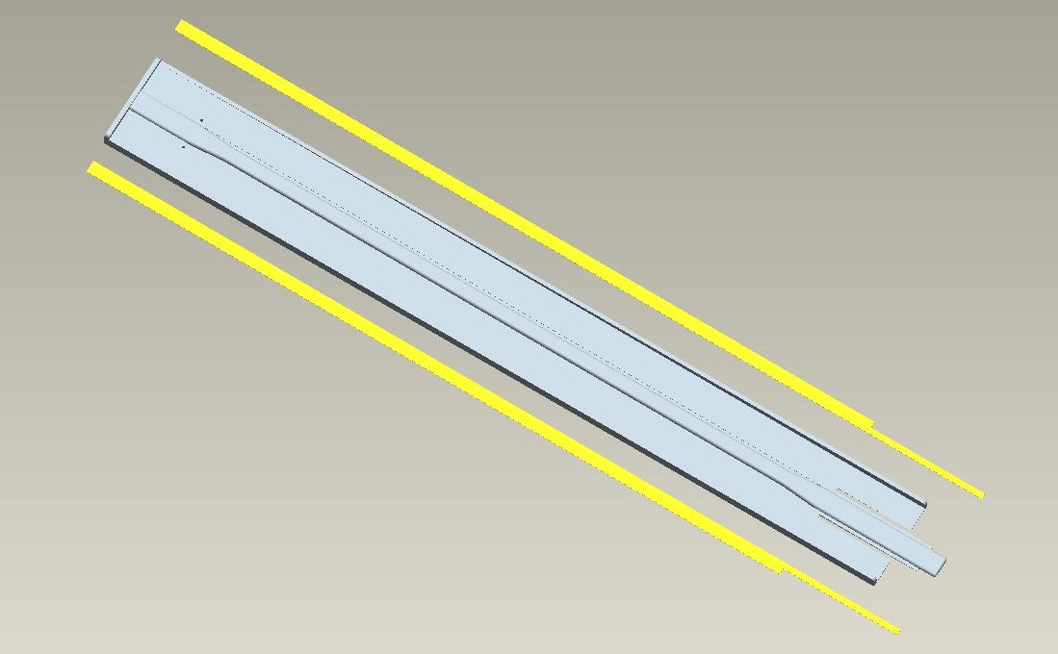

For the strong structure, the conductive brass sheet slides into the plastic body.
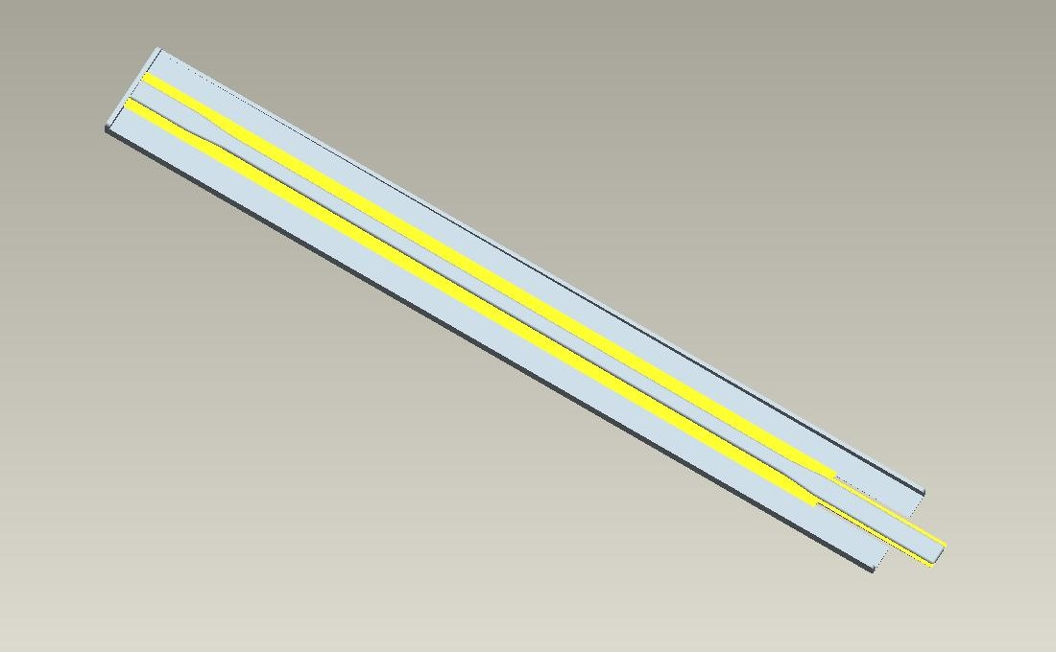

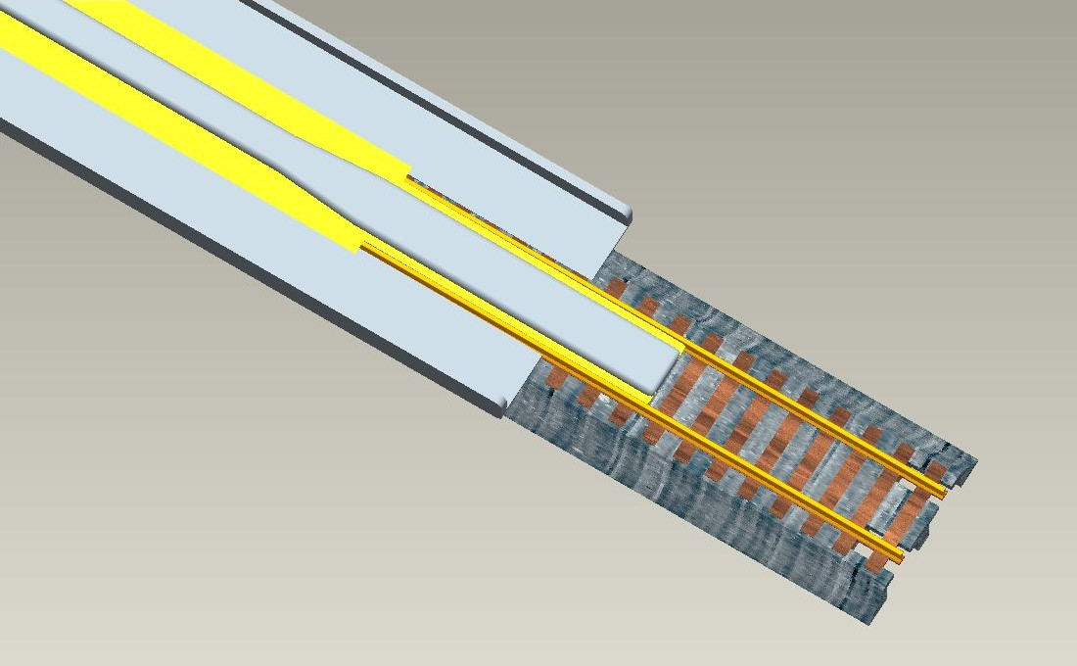

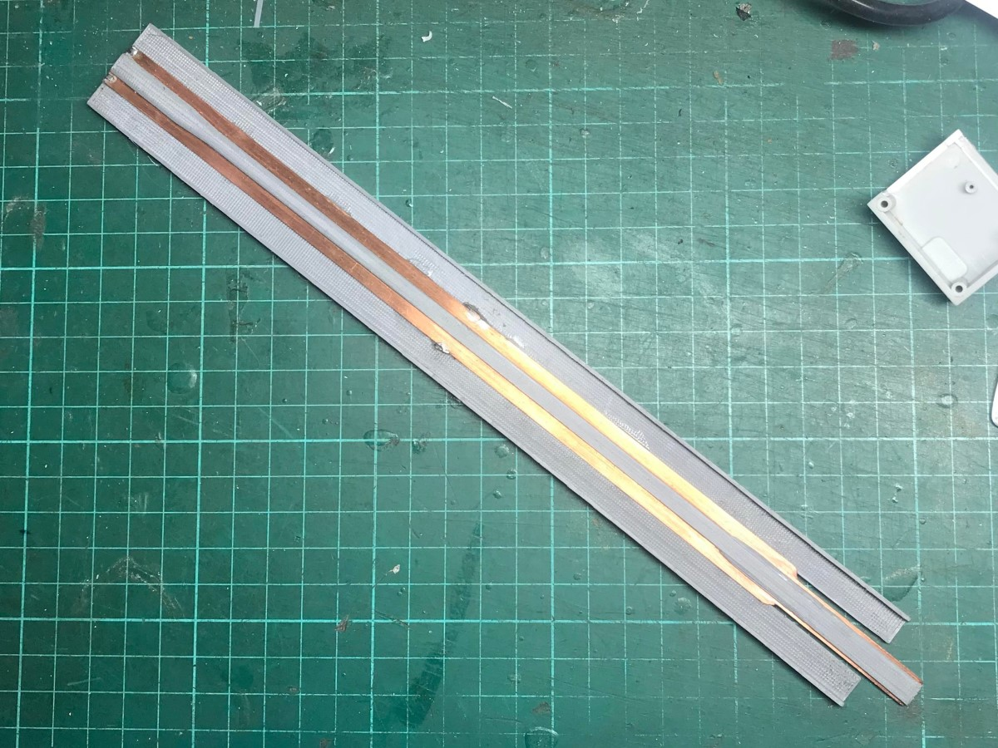

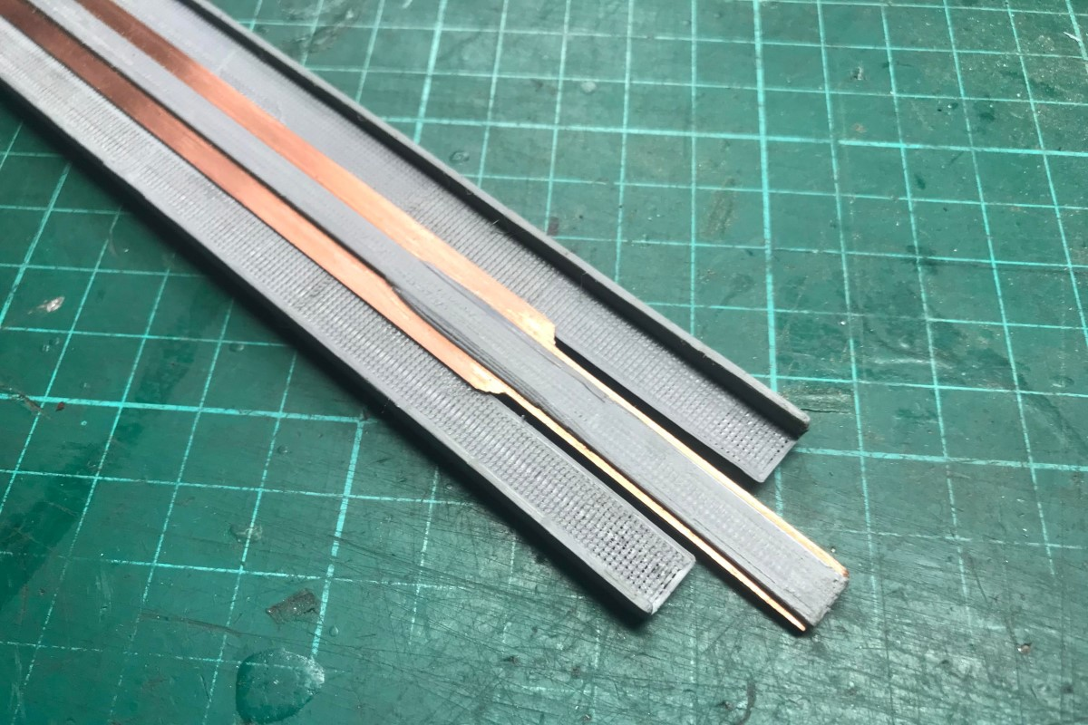

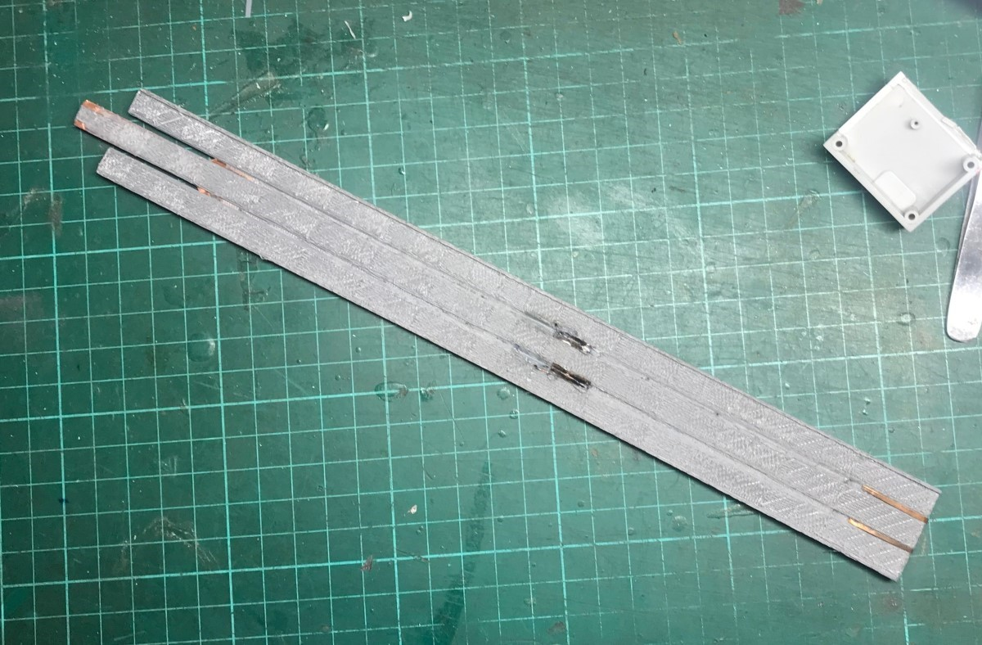

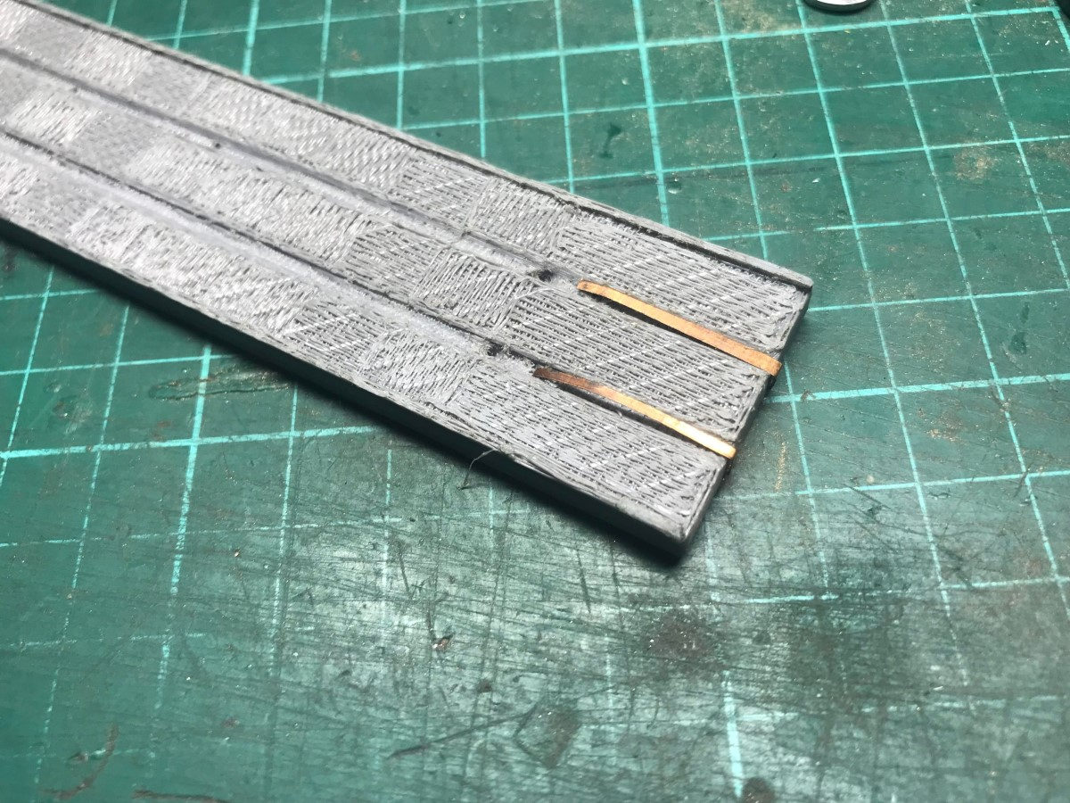

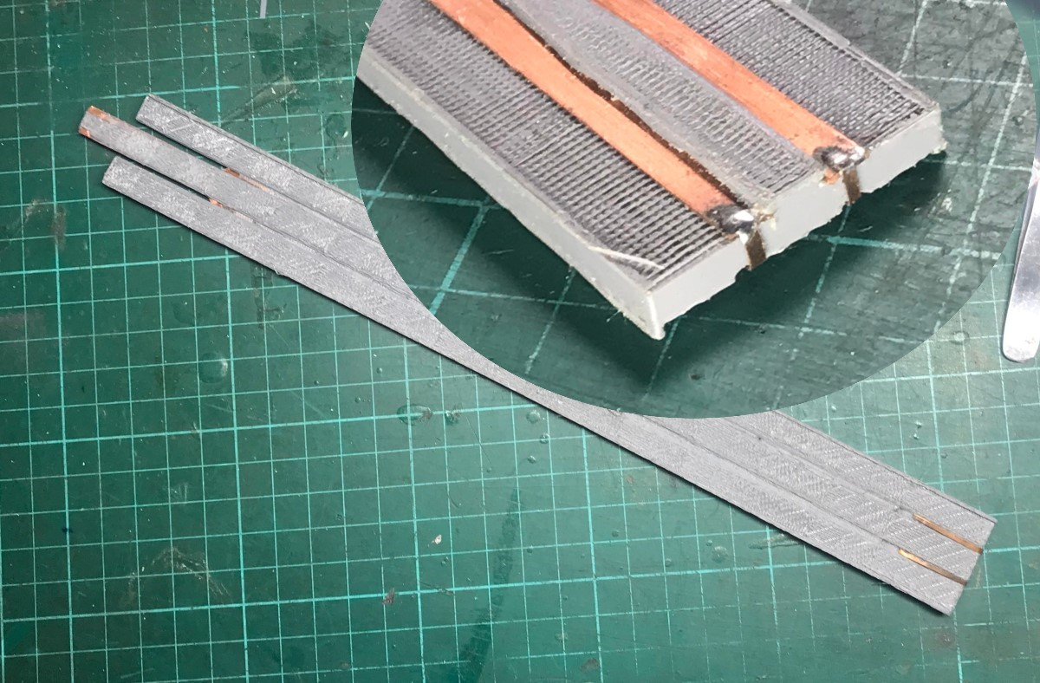

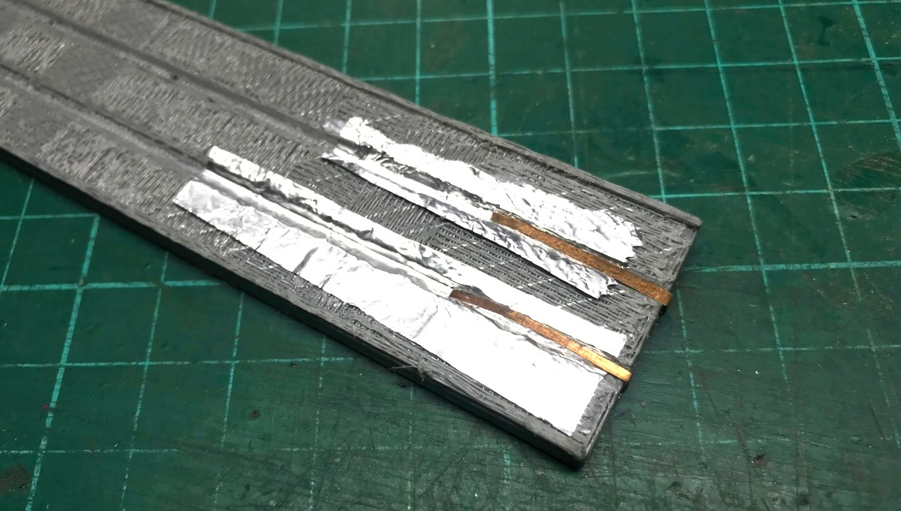

Best Regards
Taiwan Mini Train Club
Jung Fa Lee (Jason Lee)


